***QUESTION 1******(20 points)***

**a) Define traffic Intensity in a computer network.**

Traffic Intensity estimates the extent of the queuing delay in a network, in other words it

estimates how long it would take for a packet get through the queue given the average rate of

packets (in bits/sec) that get to the queue and the transmission rate at which bits can be pushed

out the queue (also calculated in bits/sec). If *La/R > 1,* then the average rate at which bits arrive at

the queue exceeds the rate at which bits can be transmitted from the queue (unstable). For a

system to be stable *La/R <= 1.* ( La is the average rate in which bits arrive to the queue in bits/sec

and R is the transmission rate at which bits are pushed out the queue also calculated on bits/sec).

**In a computer network, an entry router with a 200 Mbits link receives 200 packets per**

**second and each packet size is 400 bytes. Is the system is stable?** Stable if the result is <= 1

TI = a(L/R) <= 1

a = 200 packets/sec

Packet size L = 400 bytes or 0.0032 mbits

Bandwidth R = 200 mbits

200(0.0032/200) = 0.0032 <= 1. It is stable.

**b) Suppose N packets arrive simultaneously every (L/R)N seconds (where L is packet size, R is the transmission rate. Then first packet transmitted has no queueing delay; what is the queueing delay for the second packet?**

1st packet delay=0 2nd packet delay= L/R Nth packet delay= (N-1)L/R

Average queuing delay = [L/R+2L/R+ … + (N-1)L/R]/N = **[L(N-1)]/2R**

**c)** **Car-caravan analogy. Given:**

**-Cars propagate at 100km/hr.**

**-A tollbooth services a car at a rate of one car every 12 seconds.**

**-Tollbooths are 75km apart**

**a) Suppose the caravan of 10 cars travels 150 km, beginning in front of one tollbooth, passing through a second tollbooth, and finishing just after a third tollbooth. What is the end to end delay?**

Transmission delay = L (packet length)/R(link bandwidth) = 10 cars/(5cars/min) = **2 mins**

Takes 2 minutes for the first tollbooth to service 10 cars.

Propagation delay = Distance from B to A/Propagation speed = 75km/(100km/hr) = **45 mins**

Each car has a propagation delay before arriving to the second tollbooth.

There are 3 tollbooths = **6 mins** and total distance is 150km hence = **90 mins** which is **96 mins**

**d) In the following Fig, if Rs = 2 Mbps, Rc = 1 Mbps, R= 5 Mbps, and the common link divides its transmission rate equally among the 10 downloads.** 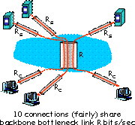

**What is the end-to-end throughput for each download?**

R has a maximum of 5 Mbps so that needs to be divided equally amongst the 10 downloads. We divide the 5 Mbps/10 = 500 kbps. The end-to-end throughput for each download is 500 kbps. (For other problems take consideration Rs and Rc.

In this problem it didn’t matter since R was 5)

**Maximum Throughput we can achieve by calculate the minimum of the access Link‘s transmission rates calculation.**

**Throughput = min(Rs, Rc, R/N) = min(2 Mbps, 1 Mbps, 5/10 Mbps)**

**= min(2 Mbps, 1 Mbps, 500 kbps) = 500 kbps**

**QUESTION 2**

***(2 Points)***

**a) What are the similarities and differences between HTTP and FTP?**

Differences: -HTTP is used to access websites on the inter, while FTP is used to transfer files from one host to the other. -HTTP uses TCP port 80, FTP uses TCP port number 20 and 21. HTTP is efficient to transfer smaller files like web pages, FT is efficient to transfer large files. -HTTP does not require authentication, FTP uses password authentication. -Web pages or data transferred to a device using HTTP are not saved in the memory, data delivered using FTP is saved in the memory of the device.

Similarities: -HTTP and TCP are both file transfer protocols. Both use TCP.

**What are the reasons web caching has seen deployment in the Internet?**

-It can reduce the response time for a client request by a lot.

-Reduce traffic on an institution’s access link to the internet, which reduces costs.

-Web caches can reduce web traffic in the entire internet, improving performance for all

applications.

***(8 Points)***

Consider the following figure, for which there is an institutional network connected to the Internet. Suppose that the **average object size is 850,000 bits** and that the **average request rate from the institution’s browsers to the origin servers is 15 requests per second**. Also suppose that **LAN bandwidth capacity is 100 Mbps** and **Access bandwidth capacity is 15 Mbps**.

**What are Utilizations: $U_{Access Link}$ and $U_{LAN}$?**

**Avg object Size = 850000 bits**

**Avg Request rate from browser = 15 request/sec**

**Access Link rate = 1.54 Mbps**

**Access Bandwidth Capacity = 15 Mbps**

**Lan Bandwith Capacity = 100 Mbps**

**Dtrans = L/R = 850000/100 * 106 = 8.5 msec**

**Traffic Intensity =** ß * **Dtrans = 15 * 8.5 m sec = 0.1275**

**UAccess Link = 8.5 * 10-3 / (1 – 0.1275) = 8.5 * 10-3 /0.8725 = 0.00974 ~ 0.01**

**Dtrans = L/R = 850000/15 * 106 = 56.67 msec**

**Traffic Intensity =** ß * **Dtrans = 15 * 56.67 m sec = 0.850**

**ULAN = 56.67 * 10-3/ (1 – 0.850) = 0.3778 ~ 0.4**

***(10 Points)***

**c)**  Write a TCP client-server application program (Client_TCP and Server_TCP) where

* client reads two numbers from standard input (**inFromUser** stream) , sends to server via socket (**outToServer** stream)
* server reads these two numbers from socket

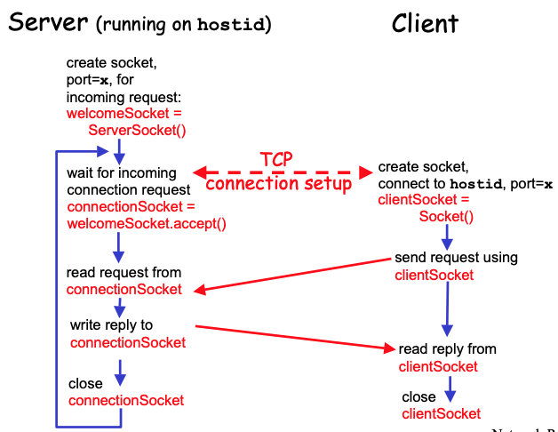

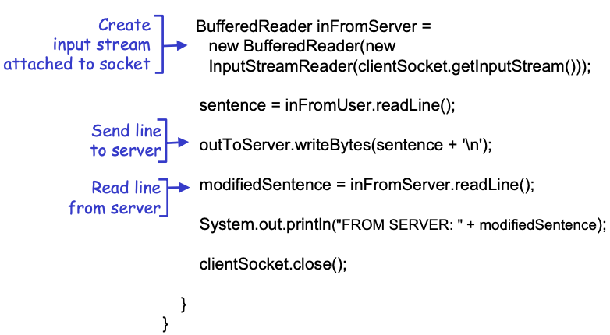

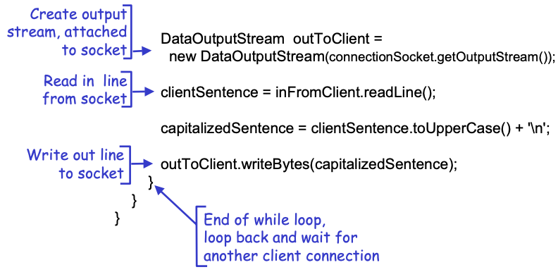

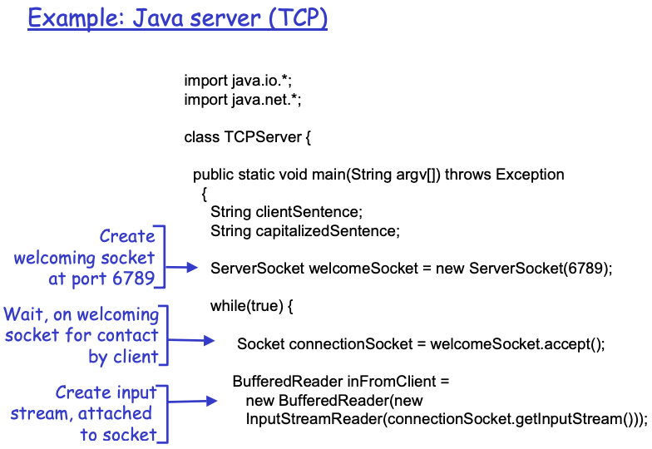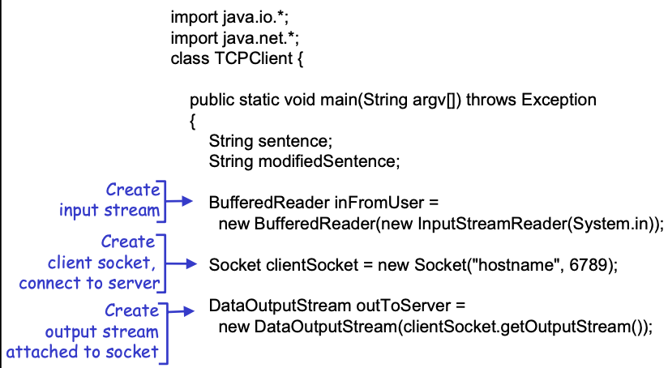

**QUESTION 3**

***(4 points)***

**a)** **What are the differences between stop-and –wait and pipelining protocol?**

-While S&W protocol will not send a segment until the previous sent segment has been successfully ack; Pipelining does not wait for acknowledgement and instead sends data in small sizes that can get to the receiver in an unorganized manner. -Pipelining is faster than stop and wait since it does not wait for ack on the previous sent package.

S&W: SENDER 1)Send one data packet at a time. 2)Send next packet only after receiver ack for previous. RECEIVER 1)Send ack after receiving and consuming of data packet. 2)After consuming packet, ack needs to be sent (flow control). PROBLEMS: Lost data. Lost ack. Delayed ack/data.

Pipelining: Message is broken into different parts that are sent independently, over the optimum route for each individual packet, and reassembled at the destination. Multiple requests are sent to a single socket without waiting for corresponding response. Improvement in performance, reducing waiting time of a process.

**How pipelining protocols help utilization in TCP/IP communication?**

(8 Points)

b) For Stop-and-wait operation calculate

1. Utilization (fraction of time user is busy sending) for the following figure with:

1 Gbps link, 15ms e-e prop. delay, and 1KB packet.

Propogation delay = 15 e-e – means it takes 30 ms to complete one Round Trip

Ttrasmit= L(packet length in bits)/R(transmission rate bps) = (1kb/pkt)/(10^9b/s)

Utilization = = = 33.3 * 10-6 seconds

3. Explain your finding in terms of network performance

(8 Points)

c) Now consider the pipelining technique with window size = 5 packets and calculate

1. Utilization (fraction of time user is busy sending) for the following figure with: 1 Gbps link, 15 ms e-e prop. delay, 1KB packet .

Propogation delay = 15 e-e – means it takes 30 ms to complete one Round Trip

Ttrasmit= L (packet length in bits)/R (transmission rate bps) = (1kb/pkt)/(10^9b/s)

Utilization = $\frac{N*\frac{L}{R}}{[RTT+\left(\frac{L}{R}\right)]}$ = $\frac{5* \frac{1000}{10^9}}{[30+\left(\frac{1000}{10^9}\right)]}$ = 0.1667 * 10-3 seconds

3. Explain your finding in terms of network performance

If we use Pipelining then the average Utilization of the Link increases by 3 times the original.

***QUESTION 4******(20 Points)***

**a) Host A and B are directly connected with a 100 Mbps link. There is one TCP connection between the two hosts, and Host A is sending to Host B an enormous file over this connection. Host A can send its application data into its TCP socket at a rate as high as 120 Mbps but Host B can read out of its TCP receive buffer at a maximum rate of 60 Mbps. Describe the effect of TCP flow control.**

Although Host A can send data at rate 120 Mpbs, the Link has a maximum of 100 Mbps. Hence Host A sending rate can only be 100 Mbps. Even at 100 Mbps Host A is sending data faster than Host B can remove it from the buffer. The receiver buffer fills up at a rate of 50 Mbps, and when it gets full, Host B sends a signal to host A in order to it to stop sending data by setting RcvWindow = 0. Host A will start sending data again when it receives a TCP segment with RcvWindow > 0. This will repeat itself each time according to the value of RcvWindow sent from Host B until all the data has been transferred to Host B.

b) Explain 3way handshake in TCP connection setup using HTTP protocol with message transactions diagram.

c) Explain how congestion control works in TCP. Define slow start, Congestion Avoidance and Fast recovery explaining the following diagram:

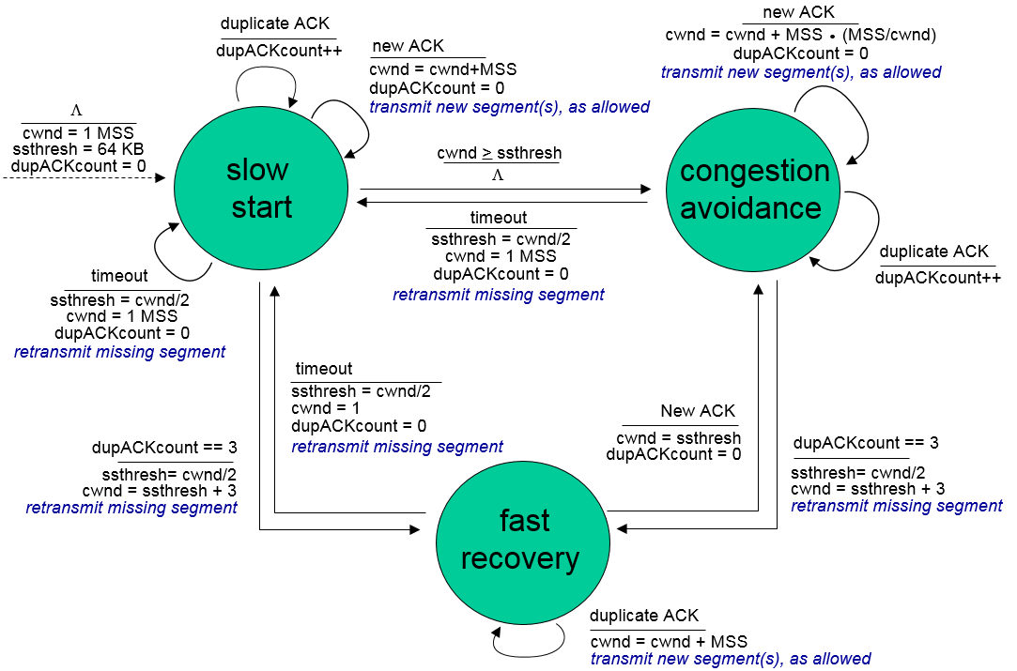

**d) Can you configure your browser to open multiple simultaneous connections to a Web site? What are the advantages and disadvantages of having a large number of simultaneous TCP connections?**

Yes, you can. The advantages of having a large number of TCP connections is the fact that the data will be transferred reliably, the data packets will be in order and lost packets will be re-transmitted. The disadvantages to this is that TCP has a congestion control mechanism and will slow down the transfer of data when the connection is congested. During this, the transfer rate will be extremely slow since there are multiple connections opening simultaneously.

***QUESTION 5* (20 Points)**

**a) Consider a TCP connection between Host A and Host B. Suppose that the TCP segments travelling from Host A to Host B have source port number *x* and destination port number *y*. What are the source and destination port numbers for the segments travelling from Host B to A?**

From B to A, the source port number is *y* and the destination port number is *x.*

**b) Suppose two TCP connections are present over some bottleneck link of rate R bps. Both connections have huge file to send (in same direction over the bottleneck link). The Transmission of the file start at the same time. What transmission rate would TCP like to give to each of the connections?**

R/2 because it distributes proportionally the bandwidth through all the users.

**c) Suppose process in Host C has UDP socket with port number 6789. Suppose both Host A and Host B send a UDP to Host C with destination port number 6789. Will both these segments be directed to the same socket at Host C? If so, how will the process at Host C know that these two segments originated from two different Hosts?**

Both segments will be directed to the same socket. The IP address is provided by the operating system to Host C for each receiving segment. This will help socket of host C determine the origin of each individual segment.

**d) Suppose Host A sends two TCP segments back to back to Host B over a TCP connection. The first segment has sequence number 90; the second has sequence number 110.**

**i.How much data in the first segment?**

20 bytes. Bytes 90-109 are in the first segment.

**ii. Suppose the first segment lost but the second segment arrives a B. In the acknowledgement that Host B sends to Host A, what will be the acknowledgement number?**

90. TCP uses cumulative acks, even if it buffers the second segment, the ack is still for the first segment.

Important Slides Chapter 1

1-25 Store and Forward

end to end delay is 2L/R with zero propagation delay

1-26 queueing delay

If arrival rate of link exceeds the transmission rate of the link:

Packets wills queue, wait to be transmitted

Packets will be dropped or lost if buffer is full

1-27 Routing and forwarding

Routing determines the route from source-destination taken by the router packet

Forwarding it moves the packets from input router to the designated route’s router

1-30 Packet and Circuit Switching

Packet switching allows more users to use the N/w

1-44 Packet Delay

Dnodal = dproc + dqueue + dtrans + dprop  
dproc = < milliseconds

dqueue = the time waiting at the o/p link for transmission

dtrans = L/R bits/(bits/sec) = sec

dprop = d/s = length of the link/ propogation speed

1-46 and 1-47 Caravan Technology

1-48 Queueing Delay (revisited)

1-52, 1-53 and 1-54 Throughput

There are 2 types: 1) Instantaneous 2) Average

Peer-connection e-e throughput – min(Rs, Rc, R/N) N – no of connections

1-60 Internet Protocol Stack

1-61 ISO/OSI Model

1-66 Network Security

Denial Of Service

Packet Sniffing

IP Spoofing

Important Slides Chapter 2

2-6 Application Architectures

2-7 Client-Server

Peer-Peer (P2P)

2-10 Sockets

**2-11** Very Important   
 How to identify multiple processes on a Host?   
 A: The IP Address and the Port No both includes in the identification of a process

2-15 Difference between TCP and UDP

2-17 Securing TCP with SSL

2-21 and 2-22 TCP Communication Explained over HTTP Protocol

2-25 Non-Persistent HTTP

HTTP Response Time = 2 * RTT + file_transferred

RTT (initiate communication) + RTT (request-response) + file transmission time

2-30 HTTP Methods 1.0 and 1.1

2-36 Cookies

**2-37 Web Caches or Proxy Servers**

It reduces time for serving Clients requests. They act as both Client as well as Servers. Clients to request data from origin server and Servers to serve data to requesting clients.

**2-39 to 2-42 Web Caching Example (There in the quiz as well as Sample Paper)**

2-58 Domain Name Systems (DNS)

**2-74 and 2-75 Peer to Peer Architecture Problem**

2-86 **DASH** – Dynamic, Adaptive Streaming over HTTP

2-90 Content Distribution Network (CDN)